Wireless Network Configuration Checklist
Prepared for: IT Staff
Prepared by: CISO Alhawra Abumouzah
Purpose: To guide the installation and configuration of secure wireless access points (APs) with NAT support for a small business office.

1. Set Up a Network Address Translation (NAT) Device
Task:
- Install and configure a NAT device (router or firewall) to manage internal and external IP address mappings.
Rationale:
- NAT allows multiple devices on a private network to access external resources using a single public IP address, enhancing security and conserving IP address space.
Recommended Device:
- MikroTik hEX S – Network Router
  - Why this device?
    - Offers robust performance suitable for small businesses.
    - Provides comprehensive NAT capabilities.
    - Cost-effective solution for budget-conscious setups.
Official Support:
- MikroTik NAT Manual

2. Determine Access Point (AP) Placement
Task:
- Strategically place three APs: two for staff and one for guests.
Rationale:
- Proper AP placement ensures optimal coverage, minimizes interference, and maintains network performance.
Considerations:
- Coverage Area: Each AP should cover approximately 50 m², considering building layout and obstructions.
- Placement: Install APs in central locations, avoiding interference from walls and electronic devices.
- Height: Mount APs 6 to 8 feet (1.8 to 2.4 meters) above the floor to improve signal coverage and reduce interference. (Cablify)
Tools:
- Use tools like inSSIDer to analyze signal strength and coverage.
Official Support:
- WatchGuard AP Placement and Channel Plan Best Practices
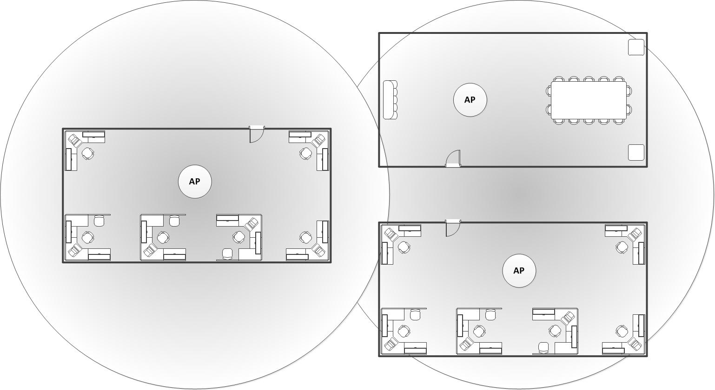

3. Configure Wireless Security
Task:
- Set up WPA3 security for both staff and guest networks.
Rationale:
- WPA3 provides stronger encryption and better protection against brute-force attacks.
Configuration:
- Staff Network: Enable WPA3-Personal with a strong passphrase.
- Guest Network: Enable WPA3-Personal with a separate passphrase; consider a captive portal for controlled access.
Official Support:
- Meraki WPA3 Encryption and Configuration Guide

4. Adjust Access Point Power Levels
Task:
- Configure AP transmit power to optimize coverage and minimize interference.
Rationale:
- Proper power adjustment ensures sufficient coverage without overlapping too much into neighboring offices.
Configuration:
- Set power levels to achieve coverage goals while reducing overlap between APs.
- Monitor performance regularly and adjust as needed.
Official Support:
- WatchGuard AP Placement and Channel Plan Best Practices

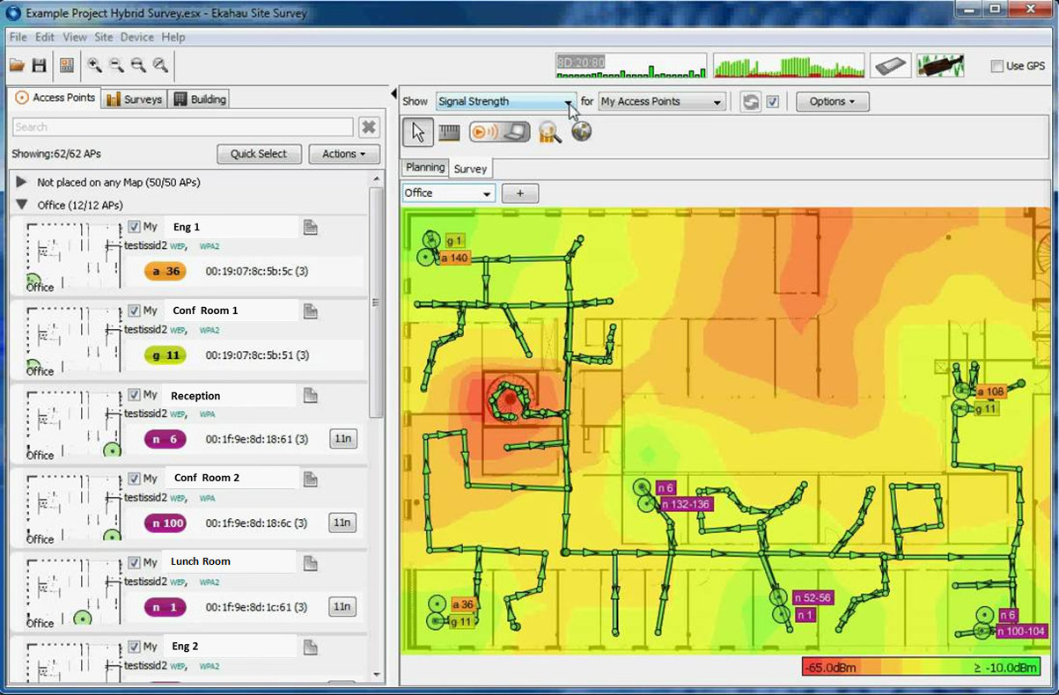

5. Implement NAT Configuration
Task:
- Configure NAT settings on the router to manage internal and external IP address mappings.
Rationale:
- NAT enables multiple internal devices to access the internet securely using a single public IP.
Configuration:
- Set up Port Address Translation (PAT) to allow multiple devices to share a single public IP.
- Configure access control lists (ACLs) as necessary to control traffic.
Official Support:
- MikroTik NAT Configuration Guide
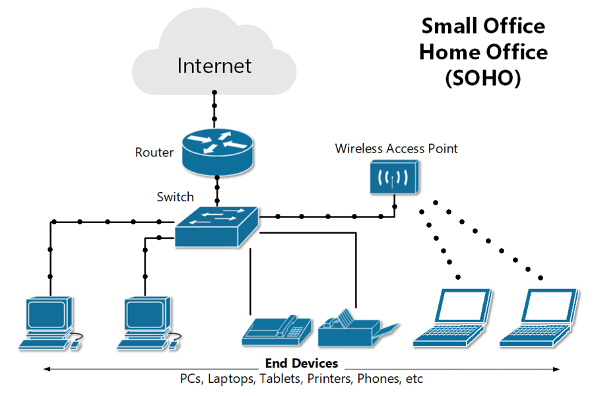

7. Final Checklist
- NAT device installed and configured.
- APs placed optimally for coverage and performance.
- Wireless security configured with WPA3.
- AP power levels adjusted appropriately.
- NAT settings configured.

